Sample Paper – DB

Section I: Write SELECT statements to achieve the following (Use join db)
- Retrieve all employees with their corresponding department names.

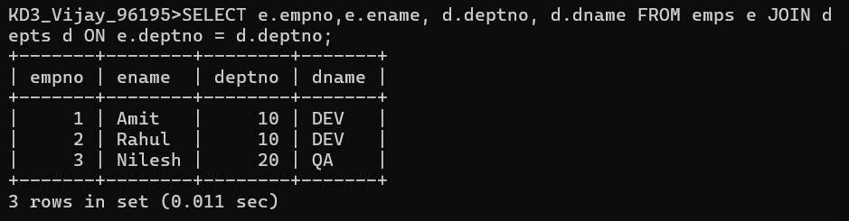

- Retrieve the department name(s) with more than 1 employees.

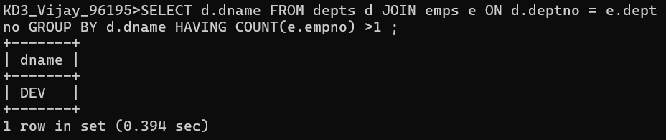

- Find employees who have attended more than or equal to 3 meetings.

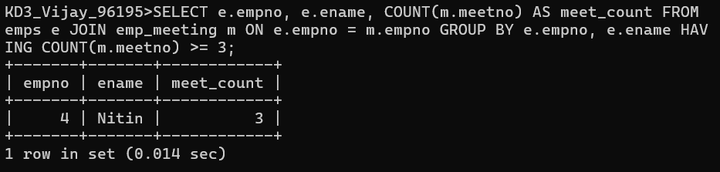

- Find the second highest department number in depts table.

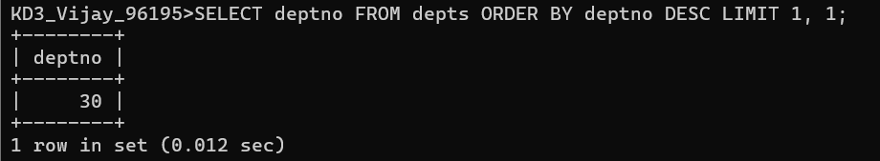

- Find employees whose empno is even and belong to the 'dev' department.

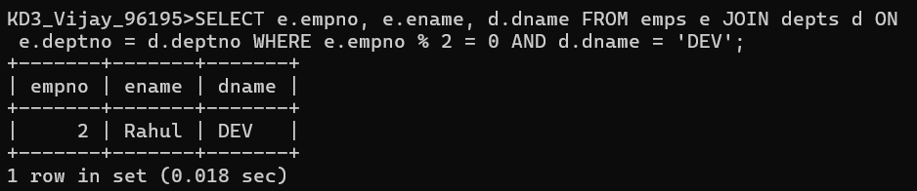

- Generate usernames by combining the first three letters of the employee's name with the department number.

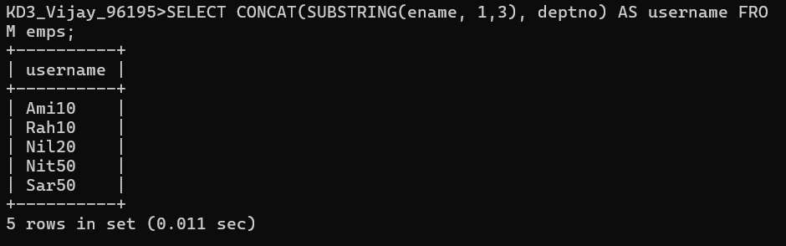

- Find addresses where the district name contains 'ara'.

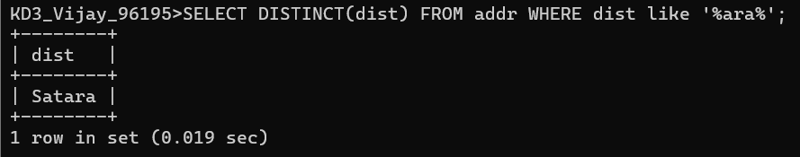

- Retrieve the last two characters of each employee's name.

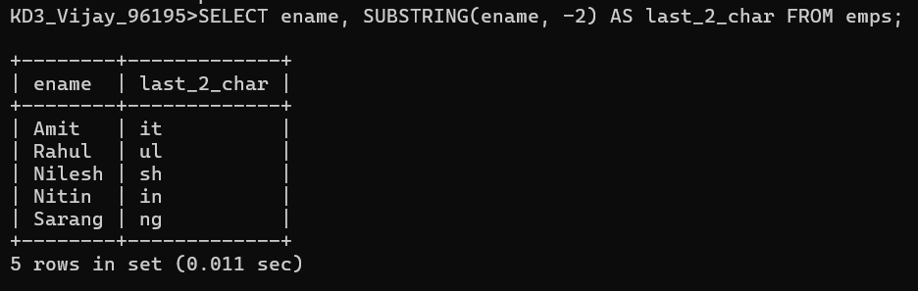

- Modify emps table using alter table command
- add following column password varchar(500).
- Insert new employee details and store password in encrypted format using any encryption function.

Section II: MySQL Program (14 marks)

- Create a procedure that takes Date of Birth from user and with respect to current system date calculates the age in years only and stores the result in temp table. Consider columns of temp table as Date (input taken from user) and Age.

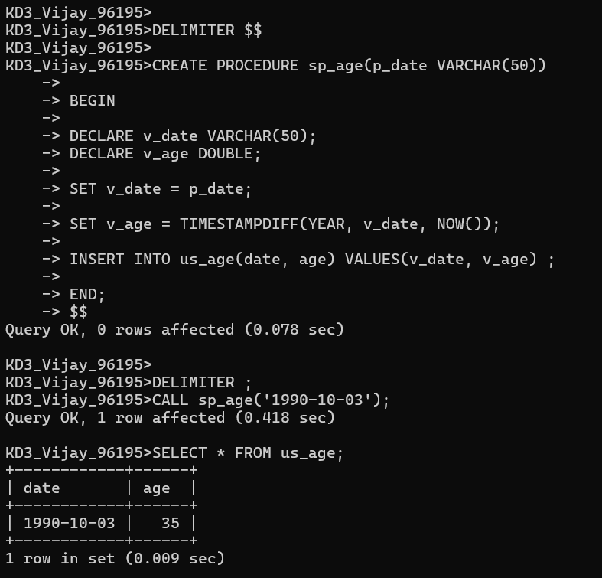

- Create a function that takes deptno as input from user and checks number of employees for that specific department and returns following message
- If no Employee in that department then return message as “No Employee Present”.
- ii) If only 1 Employee is there in that department then return message as “One Employee Present”. iii) If more than 1 Employee is there in that department then return message as “Many Employee Present”.

